How to Turn Off Google Play Protect on Android.

The Following Steps.

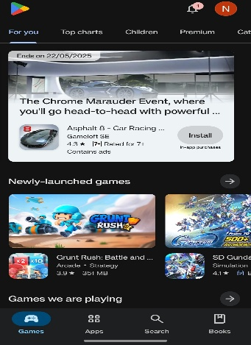
Step 1: Open the Play Store Open the Google Play Store app on your Android phone.

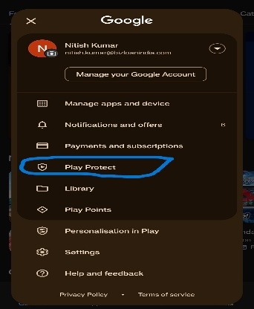
Step 2: Tap on Play Protect Tap on your profile icon in the top-right corner, then
select 'Play Protect' from the menu.

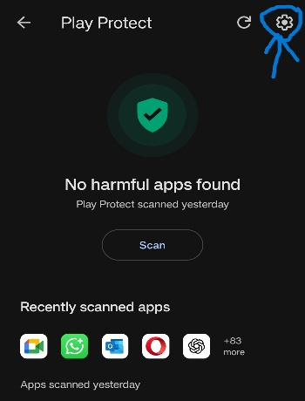
- Step 3:
Open Play Protect Settings in the Play Protect screen, tap the settings icon (gear)
in the top-right corner.

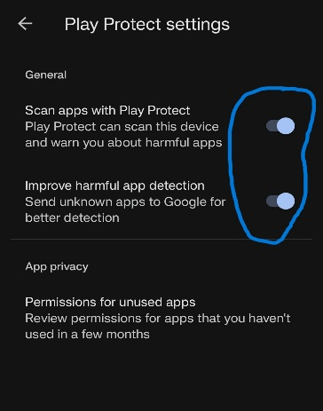
- Step 4:
Try to Turn Off Scanning You will see an option that says 'Scan apps with Play Protect.'
Tap the toggle switch to turn it off.

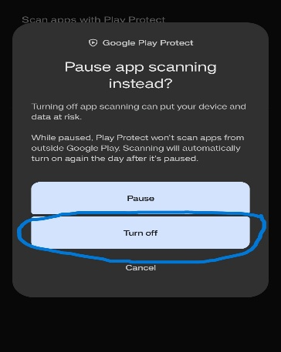
- Step 5:
Confirm Turn Off A confirmation screen will appear. Tap 'Turn Off' to proceed.

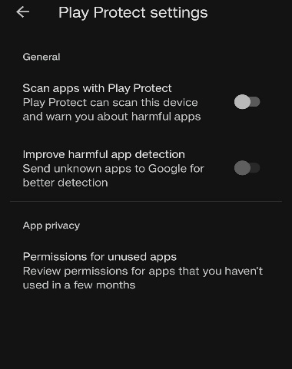
- Step 6:
Protection Disabled Play Protect will now be disabled, and your phone
will stop scanning apps for these Bizloan Applications like
‘Loan365 & Sales Buddy application’.

- Step 7:
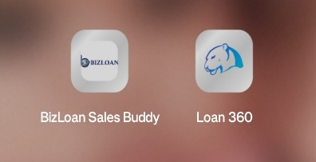
Install ‘Loan365 , Sales Buddy application’.

Link: -

